**Appendix 6**. Results of a Generalized Additive Model, demonstrating the relationship between city size and species richness.

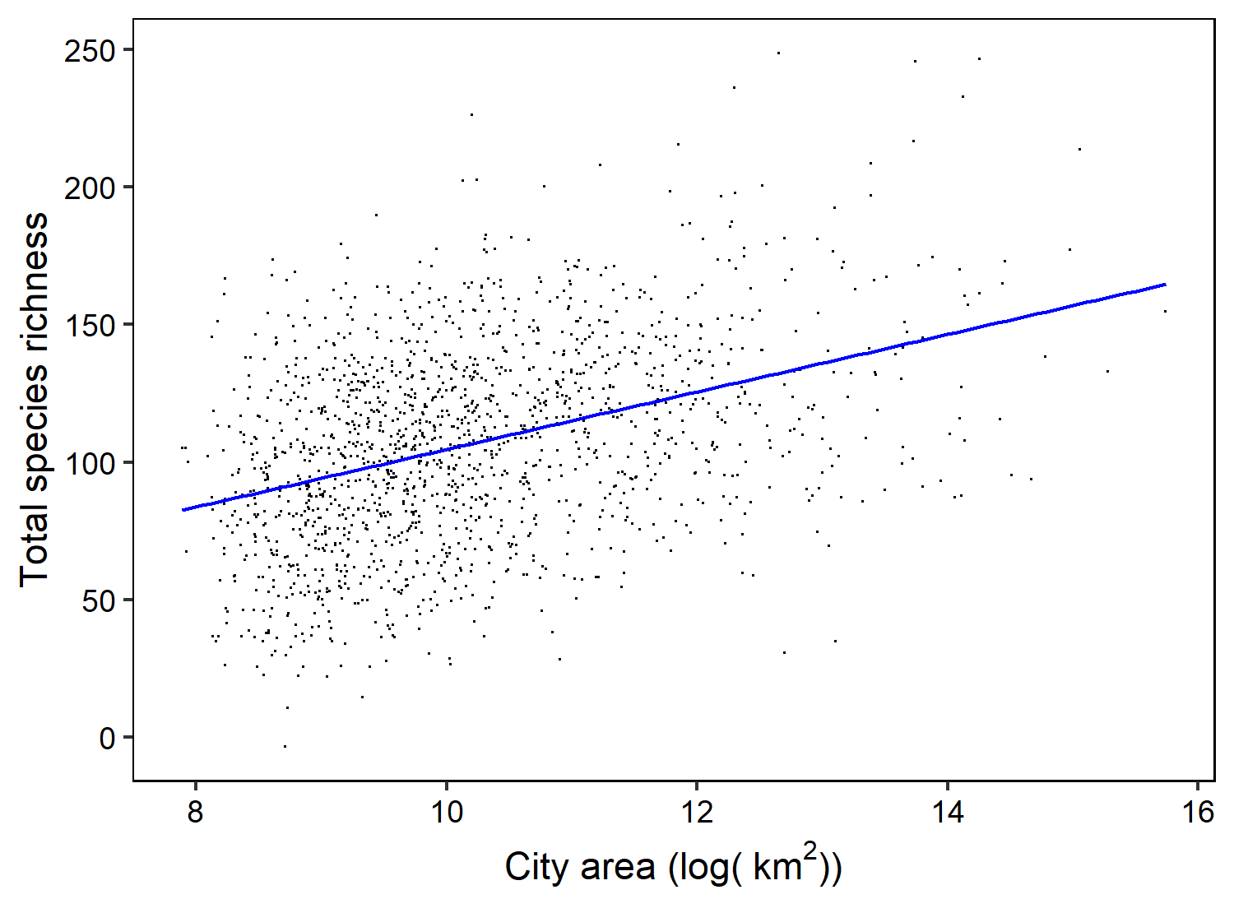

**Figure A1**. Adjusted species richness after accounting for the total number of eBird lists in a city, as a result of a Generalized Additive Model. The plot was made using the mgcViz package in R.

**Table A1**. Model results from Generalized Additive Model, where the number of lists was included as a smooth term.

Family: gaussian

Link function: identity

Formula:

total_richness ~ log(ALAND10/1000) + s(total_lists)

Parametric coefficients:

Estimate Std. Error t value Pr(>|t|)

(Intercept) 63.003 9.766 6.451 1.47e-10 ***

log(ALAND10/1000) 10.461 0.953 10.977 < 2e-16 ***

---

Signif. codes: 0 ‘***’ 0.001 ‘**’ 0.01 ‘*’ 0.05 ‘.’ 0.1 ‘ ’ 1

Approximate significance of smooth terms:

edf Ref.df F p-value

s(total_lists) 8.967 9 150.8 <2e-16 ***

---

Signif. codes: 0 ‘***’ 0.001 ‘**’ 0.01 ‘*’ 0.05 ‘.’ 0.1 ‘ ’ 1

R-sq.(adj) = 0.741 Deviance explained = 74.3%

GCV = 1123.9 Scale est. = 1116.1 n = 1581